Adding a new (recurring) Event
Hover over “+ New” on your top toolbar, and choose “Recurring Event”.
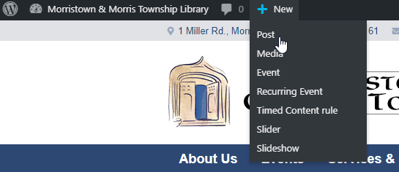
Follow the instructions for non-recurring events, but the Date/Time options will now appear below your content, and ignore the new option to add a location (this does nothing at all). If you want a location noted, just include it in your description.
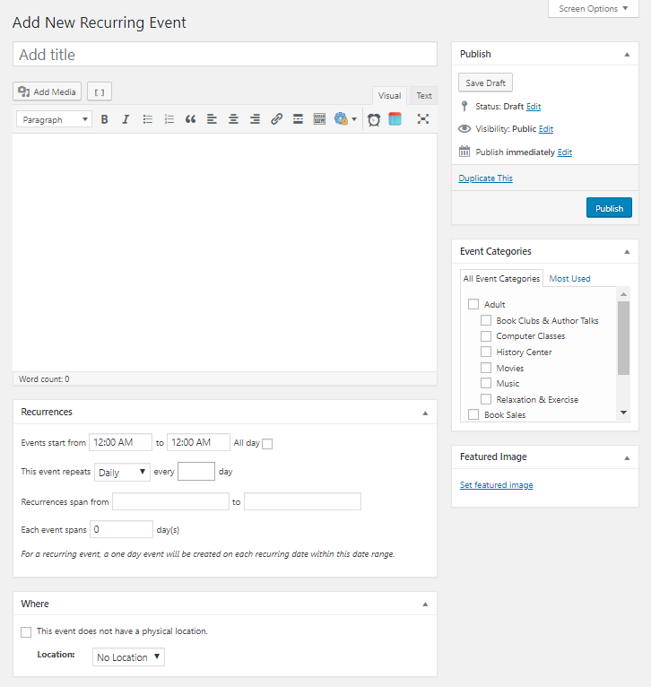
Always be sure to include a Category and a Featured Image (and a Title and a Description, but that’s obvious, right?).

