Adding or Updating Finding Aids (History Center)

Once you are logged in, click “NinjaTables Pro” on the left-hand side of your dashboard.
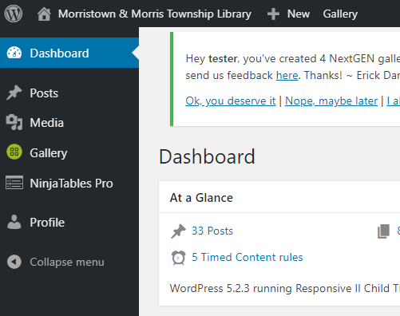

You will see multiple tables, but the only one you need is “Archival & Manuscript Collection Finding Aids”. Please ignore all the others as if they don’t exist (but don’t delete them, because that would be bad. Just ignore them.) Hover over the title and the “edit” option will appear. Click that.
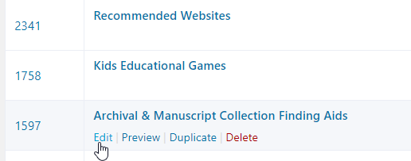
To edit a previously made entry, simply find it in the list that appears, and click on the corresponding blue pencil to the right of the title you want to edit.
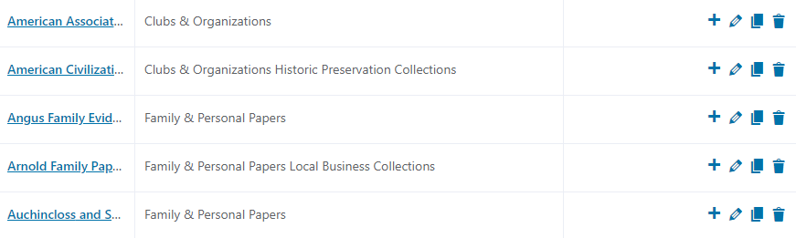
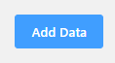
To add a new Finding Aid, in the top right corner of your screen, click the “Add Data” button. You will then see this screen:

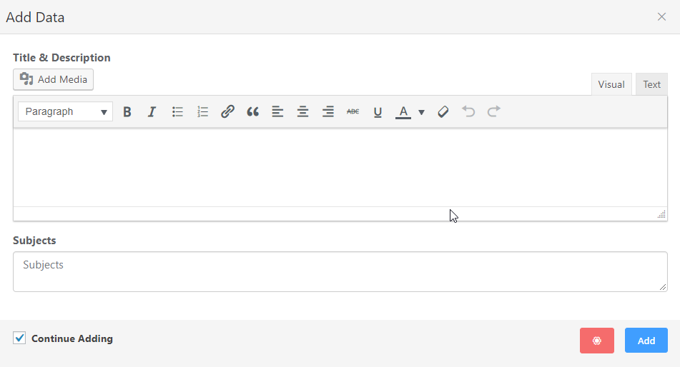
In the field marked “Title & Description” add your title, link, and description. This field works exactly the same as the old website as far as the content you want to put in it.

The “Subjects” field is new, and a little complicated. This field allows the resulting table to be sortable by subject. Right now the table has six subjects, based on what was on the old website. These are:
- Church, School & Government Records
- Clubs & Organizations
- Deeds
- Family & Personal Papers
- Historic Preservation Collections
- Local Business Collections
If you would like to add to any of these subjects, type them in, in full, no deviations, in the “Subjects” box. If you type in “Church School and Government Records” the filter system will not catch it. It must be exact, down to any ampersands or commas: “Church, School & Government Records”.

If you would like to add a new subject, go to the “Table Configuration” tab. This will be near the top of your screen when you’re already in editing mode.
Then click “Custom Filters” on the left hand menu that appears.
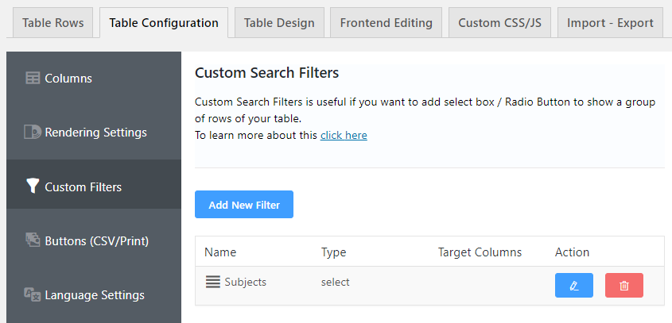

There is already a filter created called “Subjects”, in order to edit it click the blue button to the right of the title that looks like a pencil.
After clicking the blue pencil button, scroll down and under “Filter Options” you will see this:
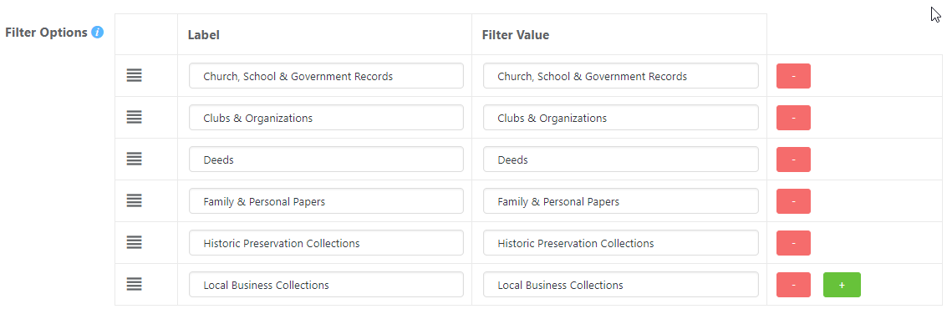
The left hand column is what patrons will see in the drop-down menu. The right-hand column is what we type in the “Subjects” box when we add data to our table. I have kept them the same in both for simplicities sake.
Technically we could make the “Filter Value” as silly as we like – it’s for our use, and the patrons never see it.
For example, if you would like to add a new subject, click the bright green button with a plus sign on the bottom right of the Filter Options.
You will see a new, empty line appear on the bottom of the Filter Options. Keep in mind your “Filter Value” can be anything, but for every new Finding Aid you add for that subject, it must be consistent. For example, if I wanted to create a new subject labelled “Flowers of New Jersey” I could do this: 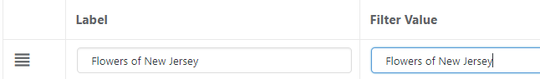
Or this:
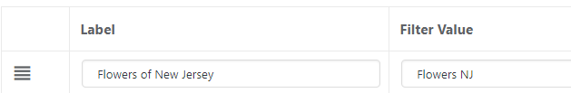
Or this:
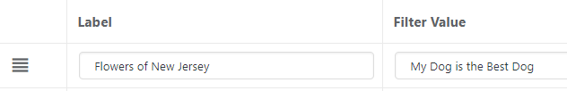
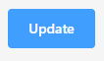
But If I do the final example that means that every time I add a Finding Aid to “Flowers of New Jersey” I have to remember that the Filter Value is a random claim about a dog I don’t own. Much easier to have it be related, and/or exactly the same.
When you are satisfied with your new Label and its corresponding Filter Value, click the blue “Update” button in the bottom right corner.
Now that you have your new subject, you can add as many Finding Aids as you like using the appropriate “Filter Value”.
Once both your new filter and at least one new data entry using it’s Filter Value are added, you will be able to navigate to the Finding Aids page and see it in action:
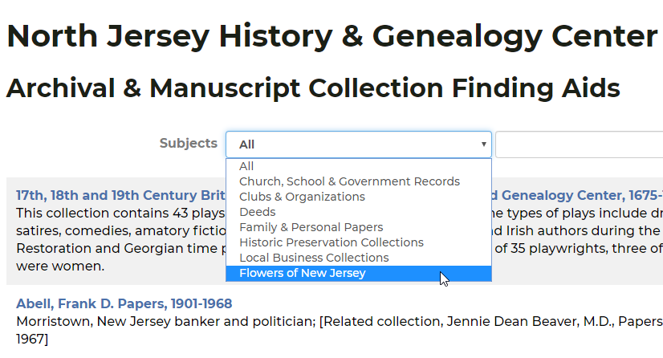

Don’t worry, I’m about to delete the “Flowers of New Jersey” Subject. It won’t really be there. It was just an illusion (example).

