To add an announcement:

- From the dashboard, select News Tickers from the left menu.
- Under the Ticker titled “MMT Announcements” choose Edit
- You should be in the “Ticker Type” screen by default.
- Edit ticker text as desired.
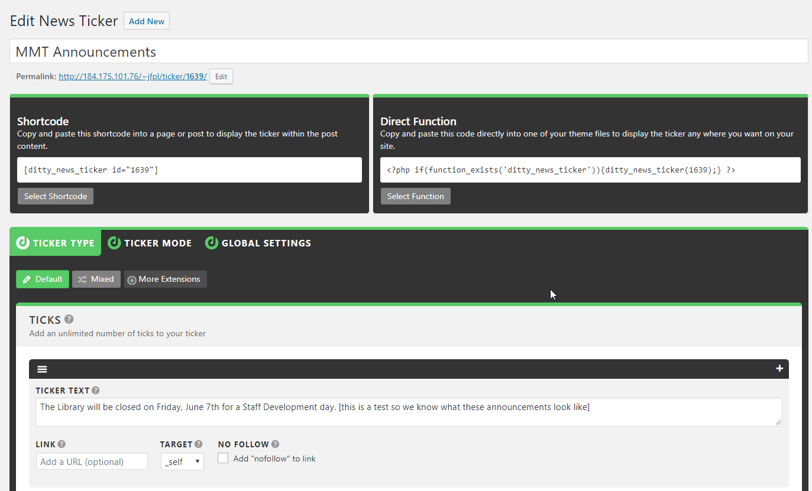

- Remove or add tickers by clicking the x or +
- Click the Update button in the right-side menu to make changes live.

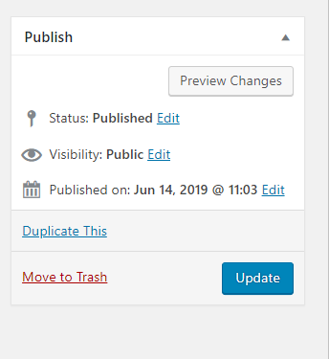

To remove an announcement:
Do not delete the ticker. If the ticker is deleted you will have to edit the shortcode that accesses the ticker on the main page content. If you don’t understand what that means, then definitely don’t delete the ticker.
Instead, do:
- From the dashboard, select News Tickers from the left menu.
- Under the Ticker titled “MMT Announcements” choose Edit
- You should be in the “Ticker Type” screen by default.
- Instead of adding text, select all text in “Ticker text” box and delete.
  - Do not leave any text in the box, not even a space.
  - A completely empty ticker box should display a grayed out message beginning “Add your content here…”
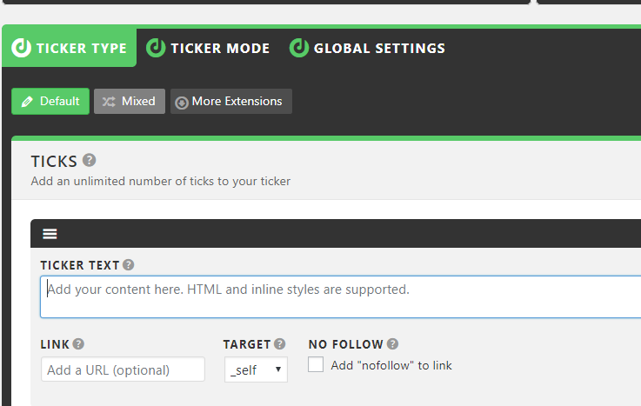
- Click the Update button in the right-side menu to make changes live.

