Creating Book or DVD Lists
From your dashboard, hover over “Bookshelves” then select “Add New” from the left hand menu.
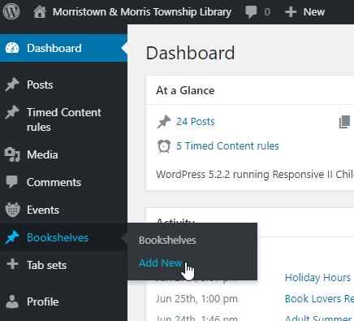

Add your title, and then paste in the ISBN for each book you would like displayed, each on its own line.
After you click “save” in the upper right hand corner you can see a preview of your list.
ISBNs here
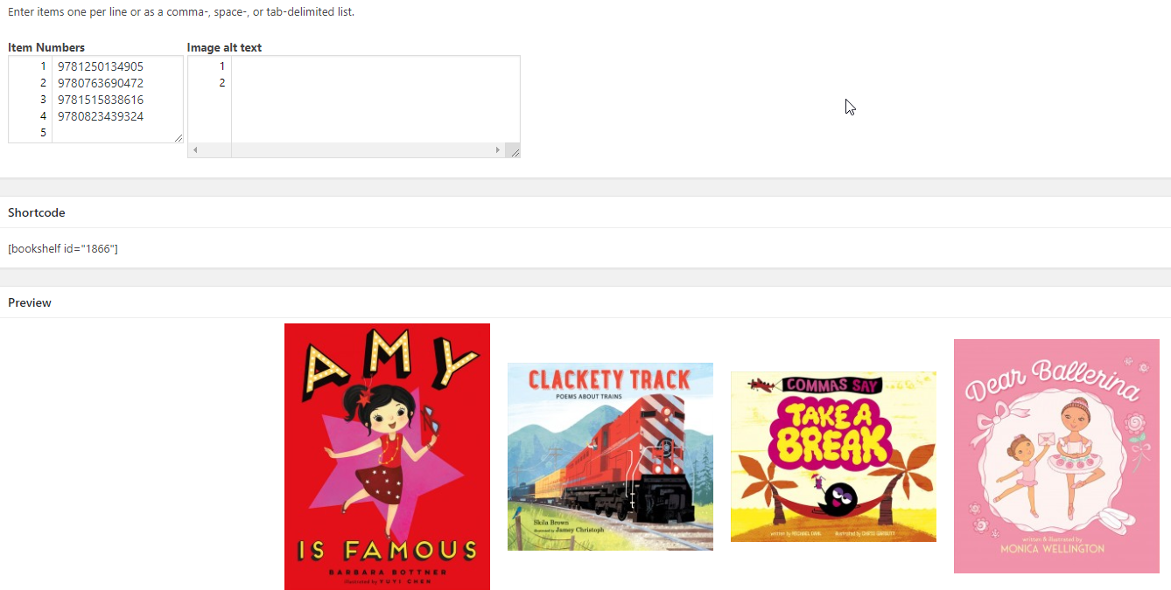
Once your book list is ready, click the blue “Publish” button on the right hand menu, and then copy the “Shortcode”. You can find this below “Item Numbers” and above “Preview”
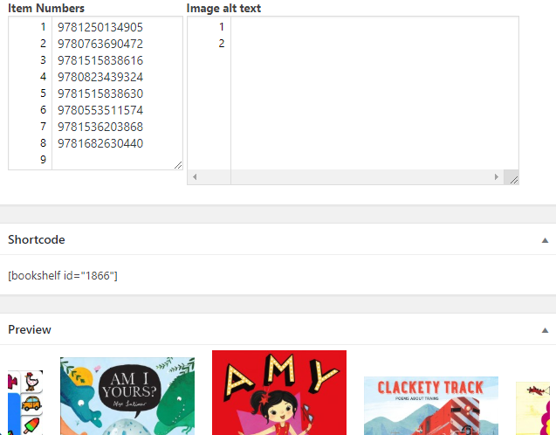

The Shortcode is unique to each booklist, and is how you place your list on a webpage. Make sure you copy everything including and between the brackets: [bookshelf id=“xxxx”].
Then navigate to the appropriate page. For Childrens: Kids Homepage, for Teens: Teens Homepage, for media: DVD Lists, for Adult Fiction: Booklists. Never edit a page that is not yours.
On the appropriate page, click “Edit Page” at the top of your screen.

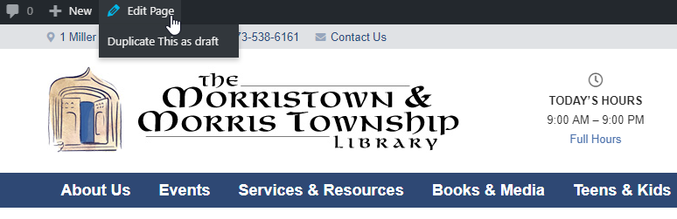
The page editor can look a little messy, but do not delete anything. You may break it. Major changes to any page must go through the website administrator.
You may however, add shortcode for your book lists.
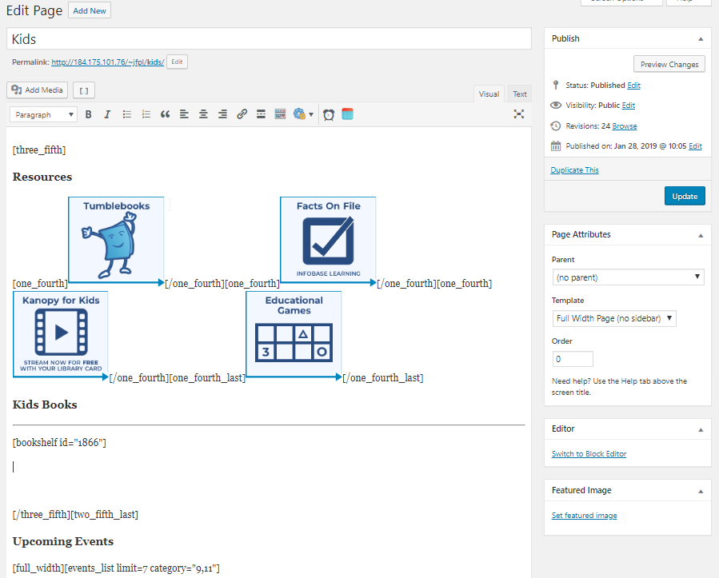
no touchy

Paste your bookshelf id in the appropriate spot.
Always click “Preview Changes” to make sure the bookshelf appears in the appropriate spot before clicking “Update”. Once you click “Update” your changes are live, for the whole world (or Morris County at least) to see.

On the front end of the website, your shortcode gets translated into the images and links to the catalog:
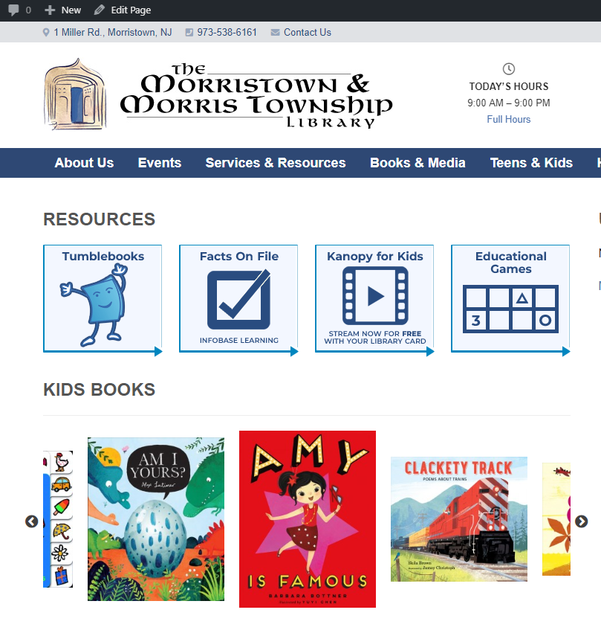
I was mere letters and numbers before, and now I am a beautiful butterfly -- *ahem* book list!

