At the top of that page, there is a "Select a menu to edit:" pulldown 1. In the pulldown, main (Header Menu) is the overall site menu, and most of the other menus (About 1, About 2, Books, etc) are the links shown within the individual columns of each mega menu. The buttons, are the items inset under each main item in the main (Header Menu)2, and the button style is defined through CSS. Each individual mega menu can be edited by mousing-over a top menu item, and clicking the blue Mega Menu button 3. Pages can be added to the menus from the left column 4.

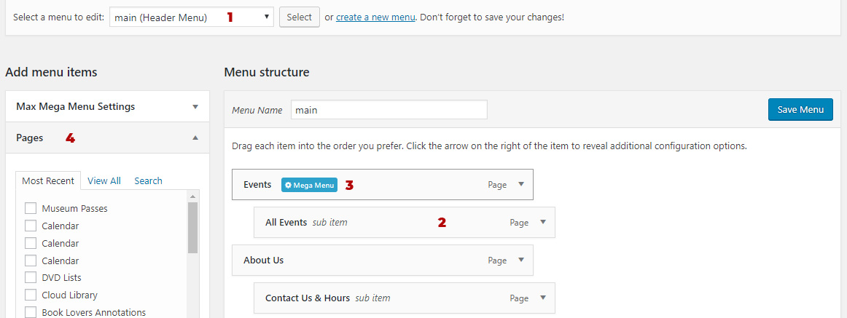
If you need to edit the first column of the About Us menu, you would select About 1 from the top pulldown. There you will find the 3 items from the left column of the mega menu. They can be reordered by simply clicking and dragging them to a new position (be sure to make sure the level remains the same horizontally). Clicking on the down arrow on the right side will open it up where you can change the name (Navigation Label), choose to open it in a new tab, or remove it entirely. If you want to add a new item, find it on the left under Pages (or use Custom Links for a link that is on another website). After clicking "Add to Menu" the new link will be listed last. Just drag it into position. Click the blue Save Menu button on the right to make it live.
To edit the buttons, you would select main (Header Menu) and add the new page the same way (through Pages or Custom Links), drag it into position, and click Save Menu. Next, click the blue Mega Menu button. Next you will see the columns of the mega menu. Drag the new button into place in the third column and click the trashcan icon on the now empty column and row where the link was to delete them. Click Save Menu again.
To style the new button, go to the site and right-click the link that is to become a button and note the ID number. Here is the code for the All Events button...
<li class="mega-menu-item mega-menu-item-type-post_type mega-menu-item-object-page mega-menu-item-758" id="mega-menu-item-758"><a class="mega-menu-link" href="http://184.175.101.76/~jfpl/calendar/">All Events</a></li>
The number to remember would be 758.
Go back to the dashboard and select Appearance/Theme Editor, and find /* Mega menu buttons */ You will find a series of two styles, one for the link styles, and one for the link hover styles. Copy the last one in each from the last comma to the end, and paste it on the end. Change the number to the new ID and then repeat for the hover one.
Link code to be copied and pasted with ID number highlighted...
, #mega-menu-wrap-header-menu #mega-menu-header-menu > li.mega-menu-megamenu > ul.mega-sub-menu li.mega-menu-column > ul.mega-sub-menu > li.mega-menu-item-846 > a.mega-menu-link
Once that's done, scroll to the bottom, and click Update File to make the new style live on the site.
If reloading the page doesn't show the new style, you may need to open and reload the stylesheet in your browser, and then refresh the page.

