Ninja Tables Pro

This plug-in can be accessed from the left-hand menu while in administrator mode.
Instructions made by the developers of Ninja Tables Pro can be found in the “Help & Documentation” tab, under the “User Guide” heading.
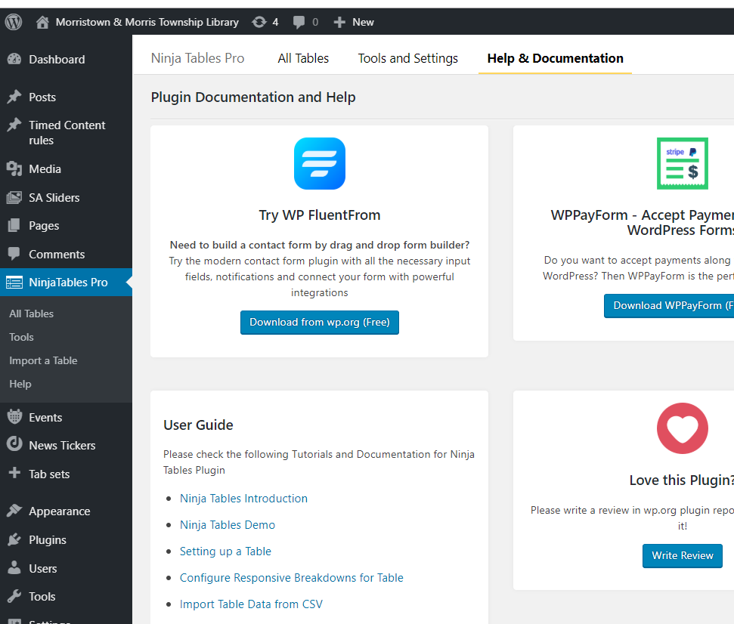
Any of the links under “User Guide” will bring you to the Ninja Tables Website, where you can also find additional subjects on their Documentation page: https://wpmanageninja.com/docs/ninja-tables/

Our version of Ninja Tables is “Pro” because we purchased it. “Pro” gives us access to all editing abilities and extra features of Ninja Tables, which has been useful for our tables such as the Research Databases table, where we would like to implement custom browsing fields (History, Science, Literature, etc).

Ninja Tables Pro includes a lot of features, so these instructions will cover a couple of the basics. For further experimentation, please see Ninja Tables’ documentation.
From the “All Tables” tab (accessible from left side or top menu) you can add a new table or edit an existing table.
To edit an existing table, hover over the table name and click “Edit”.
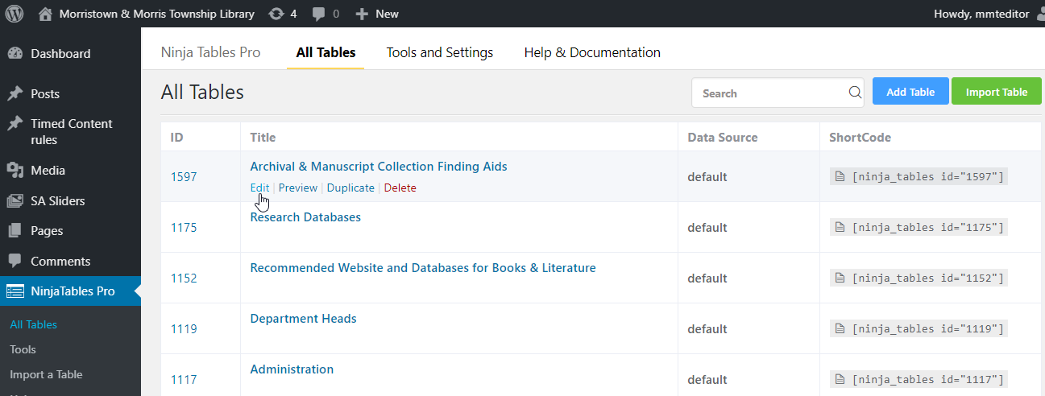
The other most important thing on this screen is the column called ShortCode on the right hand side. If you hover over and of the ninja_tables ids”these, you will see a tool tip that says “Click to copy shortcode”.
Shortcode is important to implement your table on the front end of your website, exactly where you would like it on a particular page.
In order to do so, once a table is created and ready to go, you must copy that tables unique shortcode and then paste it where you would like the table to go on the page. For a more in-depth explanation of this process, proceed to page 3.
For a tour of Ninja Tables features, go to page 5.

Example of Shortcode in WordPress and Ninja Tables Pro

When editing a web page, we can use “shortcodes” from various plugins to implement their features on the page in question. For example: There is a table on the “Reader’s Resources” page, and patrons see the page content, followed by the implemented table, like this:
content
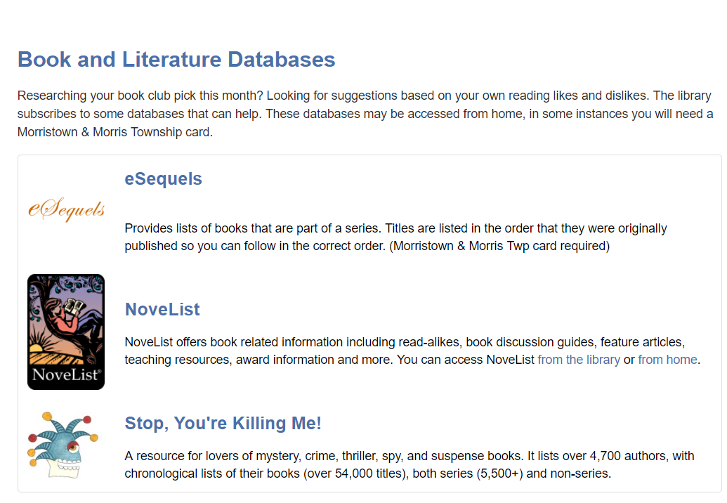
table

Whereas, when administrators are in the page editor, it looks like this:
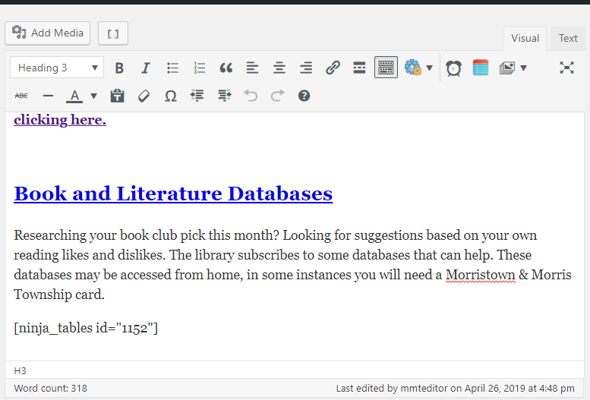
table
content
Shortcode [continued]
While the shortcode remains on the page, any edits we make to the table through the Ninja Tables Pro editor will be reflected. Each table has a unique ID, so if you would like to display multiple tables in a row, you must paste multiple shortcodes in a row.
For example, on the “Contact Us” page, there are three tables, one after another. In the editor, you can see three unique shortcodes pasted in, and the shortcodes pull the information from where we created it in the Ninja Tables editor to the front-end of our website.

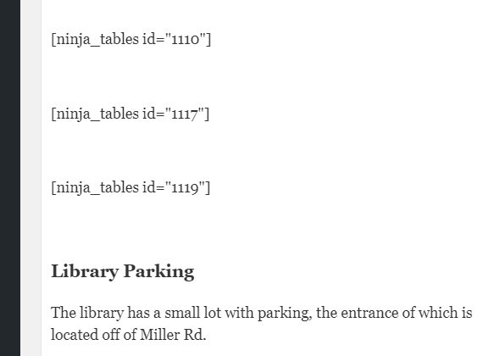
Editor View Front end view
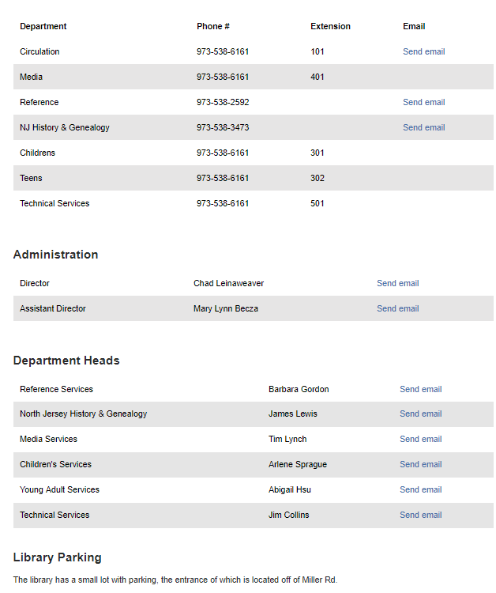

When editing a live table (meaning its shortcode is already on the page, and it is is visible on the front-end of the site), there is no need to adjust the shortcode that already exists in that page’s editor. Any edits you make to live tables will automatically appear when the page is refreshed.

Features of Ninja Tables Pro
For a look at some of Ninja Tables features, let’s look at the Research Databases table.
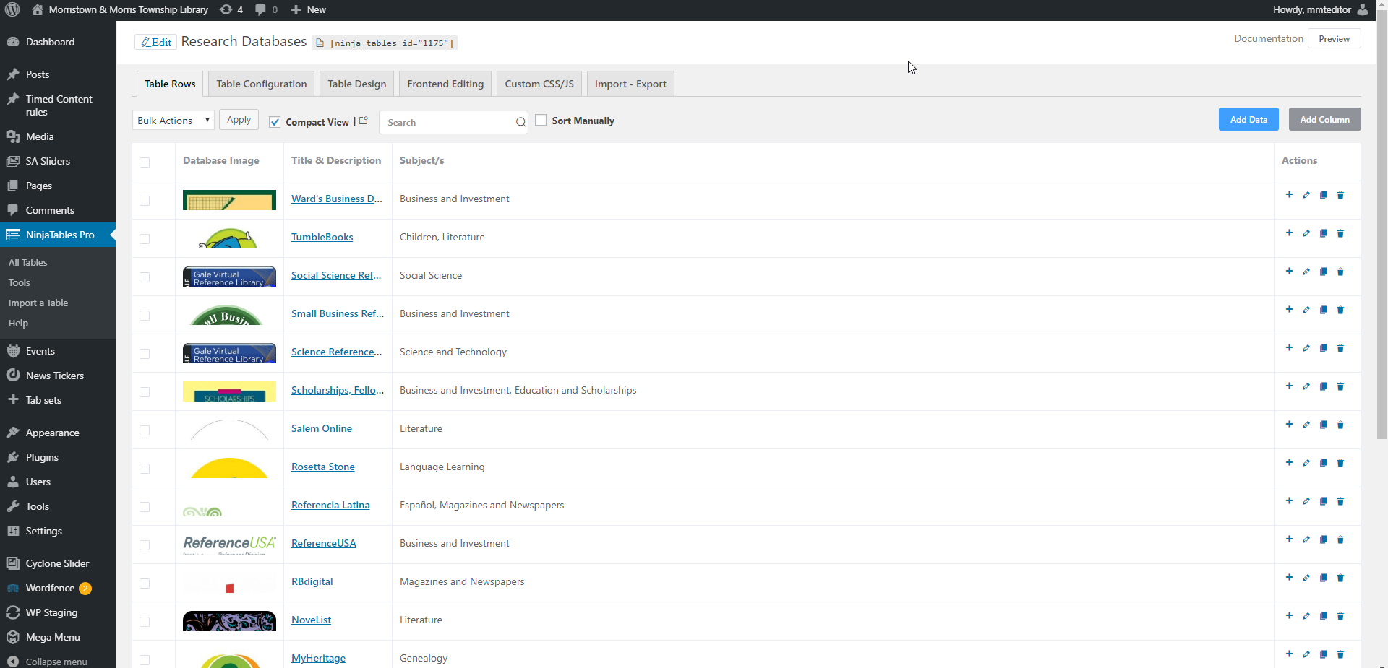
This table has three columns, which, in the Ninja Tables editor, we only see a preview of what is in each. If we edit a particular row, the editor for that single row looks like this:
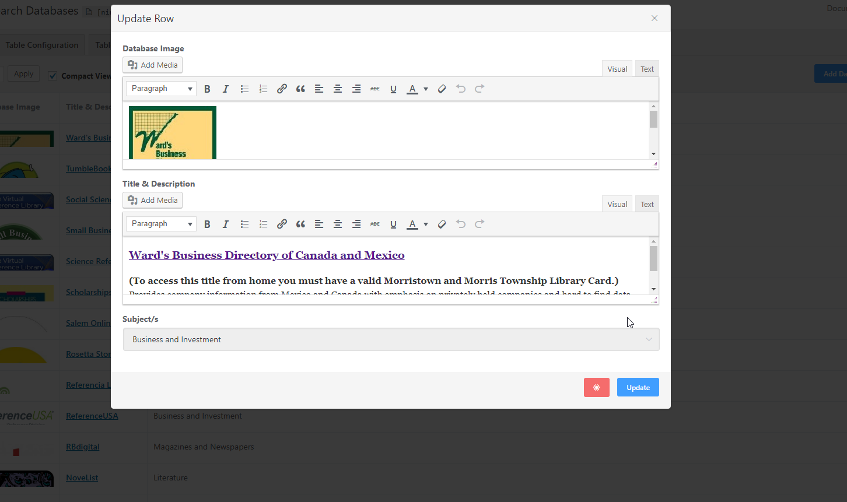
The topmost text area is the leftmost column for the Ward’s Business Directory row. In this view we can edit each column for a single row in detail.
In the Research Databases table, only two of its column are visible on the web page. It’s third column is so that we can create a menu of subjects patrons can browse by, and is only really for our behind the scenes use.
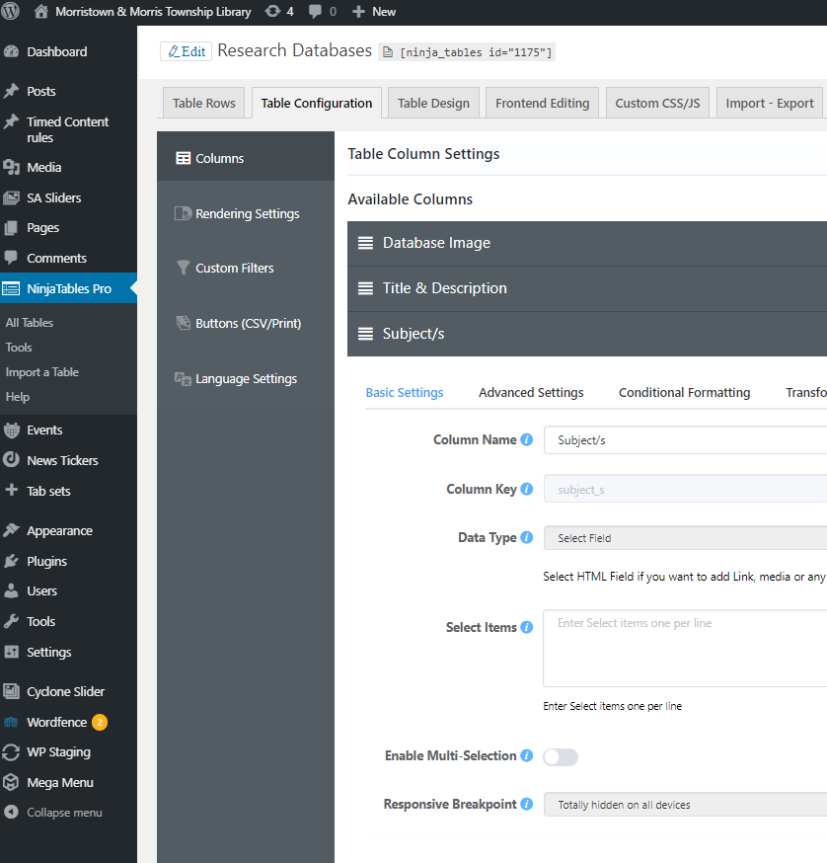
Under the “Table Configuration”tab is where you set what kind of field (Data Type above) you would like in each column, and each columns visibility on the front end of the website. Here you can see that for the Subject’s column, the “Responsive Breakpoint” is set to “Totally hidden on all devices”.
By default, the Data Type is set to Single Line Text Field, but if you would like to add any links or images to your table you must change the Data Type for that column to HTML.
In the Research Databases table, we have two HTML columns, and one simple “Text area” column. The first HTML column is so that we can insert the image for each database.
The second HTML column is so that we can insert a link to the databases’ website.
The third, simple text column, is where we can choose the subjects associated with that database, in order to create a list of subjects that patrons can browse. This is the front-end view of the table, on our Research Databases page:
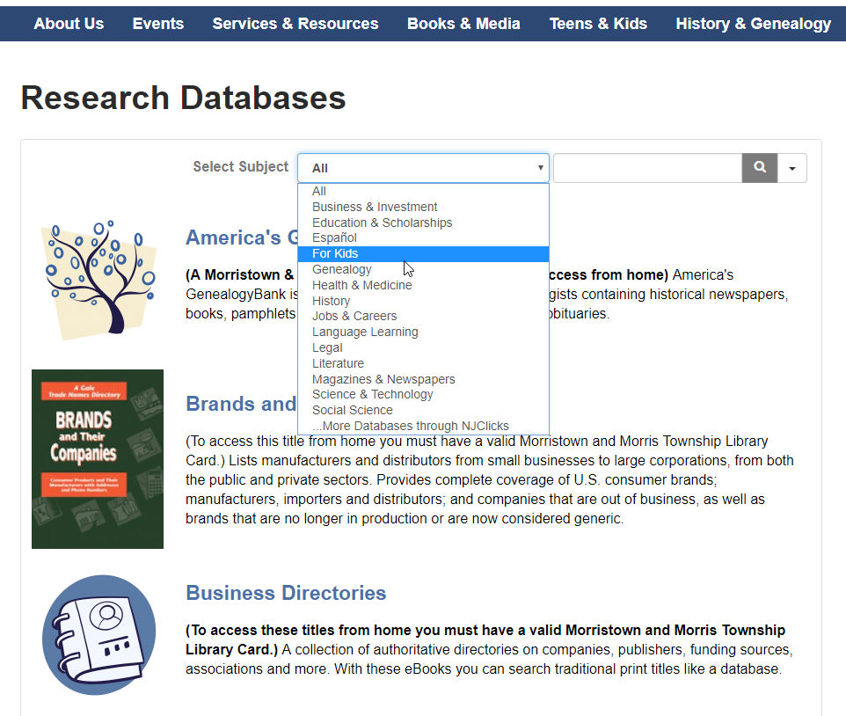
We can clearly see two column, one of images and another of title, link, and description. The third, hidden column is being used to generate the drop-down list of subjects, which requires another step to create.

Creating drop-down filter menu’s in Ninja Table
Back in our Ninja Tables editor, in our Research Databases table under the “Table Configuration” tab, look for the option in the second left-hand menu titled “Custom Filters”.
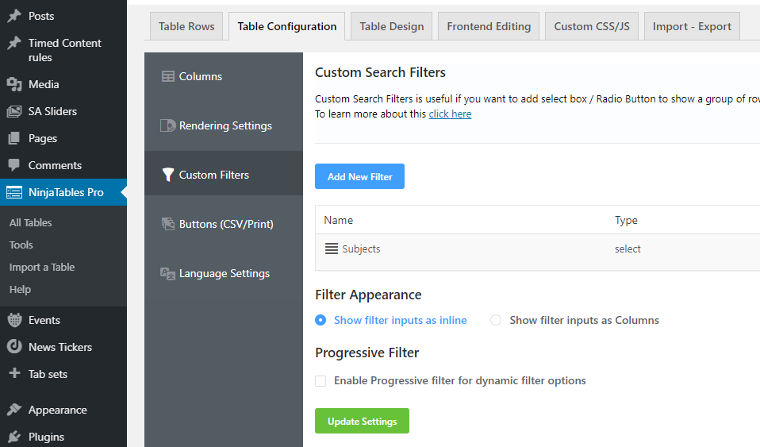
From there, you can add new filters, or edit any already in place. For the Research Databases subject drop-down menu, let’s look at what settings were used. To view them, click the pencil icon to the right of the filters name:
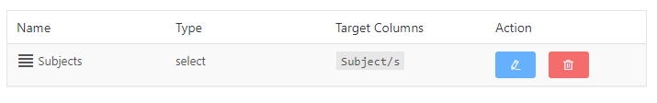
This brings up the editing screen, with multiple fields, some of which you can easily ignore, and each one has a lowercase “i” next to it which, if you hover over it, will explain what that field is for.
For instance:
“Filter Title” is what we see on our end, while “Filter Label” is what will appear in the menu that patrons see on the front end.
“Filter UI Type” is the style of menu you would like to use, and the choice will depend on what kind of table you are making. Since I want to filter by subject, I chose “Select dropdown” which will show a dropdown menu of every subject.
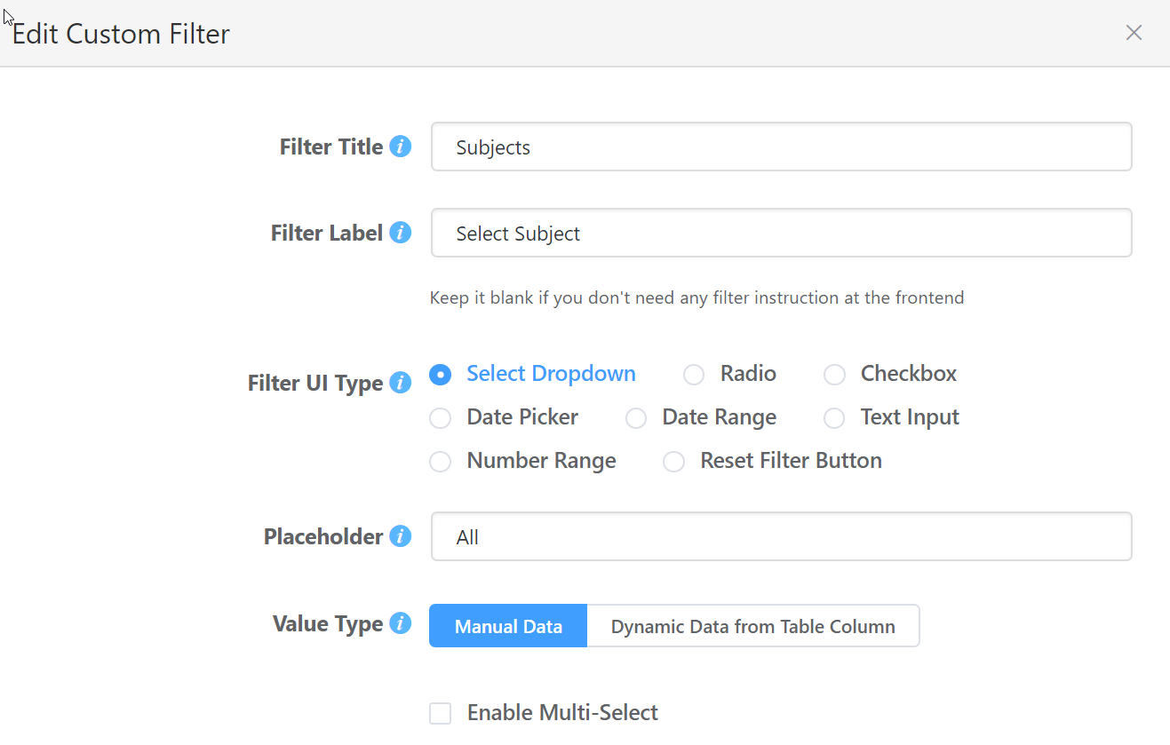
The “Placeholder” of “All” is default, and can usually be left alone. For this table, since some databases had multiple subjects, I had to create a “Manual Data” filter. That means, under the “Filter Options”, I will manually add each term I want the filter to use.

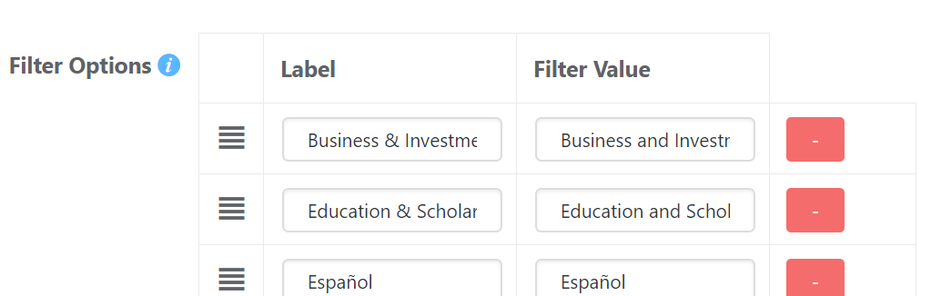
“Label” is what will appear in the dropdown menu for patrons to see, and “Filter Value” is what the filter will look for in the column we specify. So, for the “Business & Investment” filter I could of written “BAI” or “B&I” in the actual Subjects column for every Business and Investment database we have. It would have saved on typing time, but for easy of memory and association, I left it simple, only changing “and” to “&” in the Label that patrons see.

The last thing to do is choose which column this filter will search for our terms in.
After we have entered all our search terms (for now, at least. You can always come back later and edit the filter or add more), there is the “Filter Columns” option. If I wanted to, I could check every column in this table. In this case, I chose only the “Subject/s” column, which I curated and I know includes all subjects we had previously associated with the particular database.
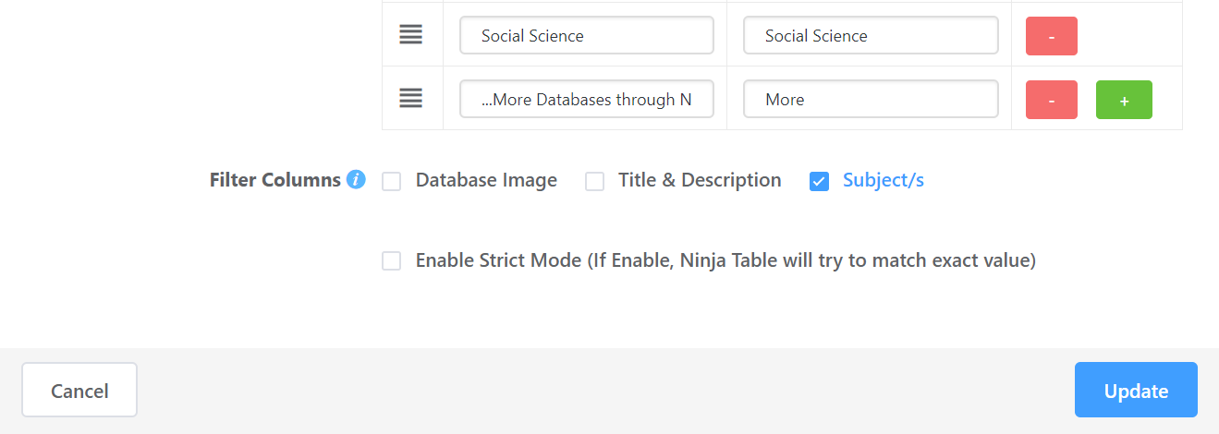
“Strict Mode” is not something I have found necessary, yet.

To finish editing your filter, simply click “Update”. If you are working on a new filter you just created, the blue “Update” button will instead be a blue “Add” button.

Features in Ninja Tables Pro [continued]

The next tab we want to look at is the “Table Design” tab.
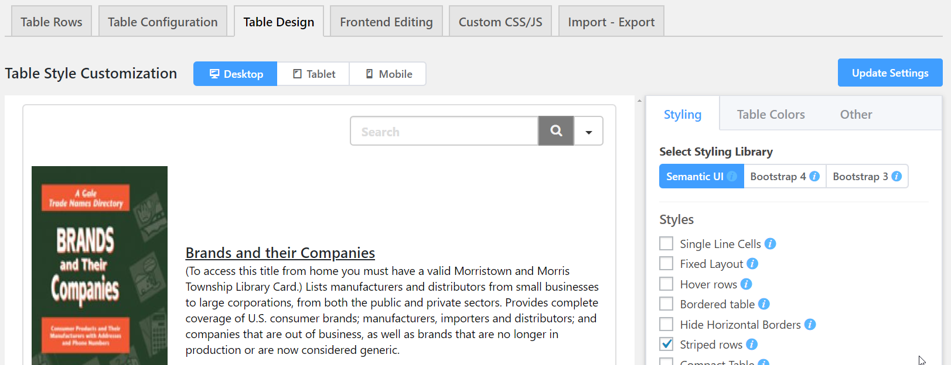
In the “Table Design” tab you have a usually somewhat incorrect preview of your databases, and a further set of tabs for styling it to the right. In this preview, the content is correct, but the picture is elongated, the drop-down filter is not there, and the background/link styling is incorrect.
But on the actual Research Databases webpage, it appears like this:

The picture is fine, the drop-down is present, and you can see the styling of background and links. So, when adjusting tables styles, keep the live version of the table open in another tab, so you can compare updates without the faulty preview module. To style tables we will be using the right-hand menu’s options “Styling” and “Table Colors”.

While the current settings for the design is not a hard and fast rule, the tables so far on the website have some elements in common, and for consistency sake any new tables should either follow the same style or the old tables should be adjusted to any new preferred styles.
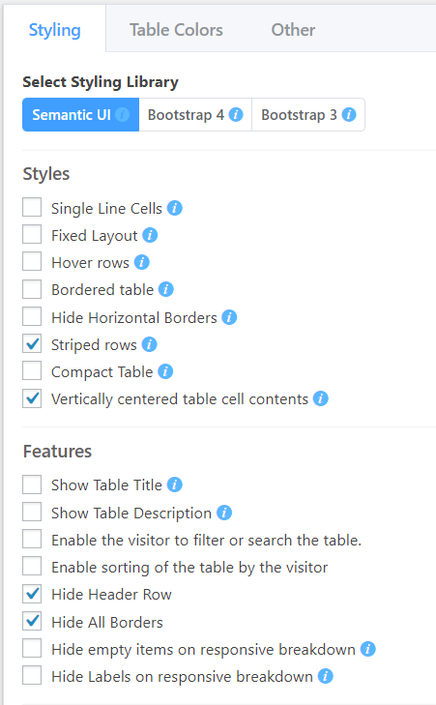
Under the “Styling” tab I use the “Semantic UI” style.
I generally have “Striped Rows”, “Vertically centered table cell contents”, and “Hide all Borders” checked for every table. For many, I find I can also check “Hide Header Row” as the table is self-explanatory.
For all tables so far, I’ve un-checked “Enable sorting of the table by the visitor” as it is unnecessary in most cases and may just cause patrons confusion.
The only databases that have “Enable the visitor to filter or search the table” on are the Research Databases table and the Archives & Manuscript Collections table, as it is unnecessary on other, smaller tables on the site.
There is only one table I have not only left borders on, but also checked “Bordered table”; that is the Bookmobile schedule table. The bookmobile table may be in need of some reworking – it was my first experiment with Ninja Tables.

Next, under the Table Colors header, some standard colors I have been using (these can be changed in the future to suit new branding schemes, etc).
For consistency’s sake, it is best to use the rgba code for the color. Those boxes with the checkered background are set to “transparent”.
RGBA Codes:
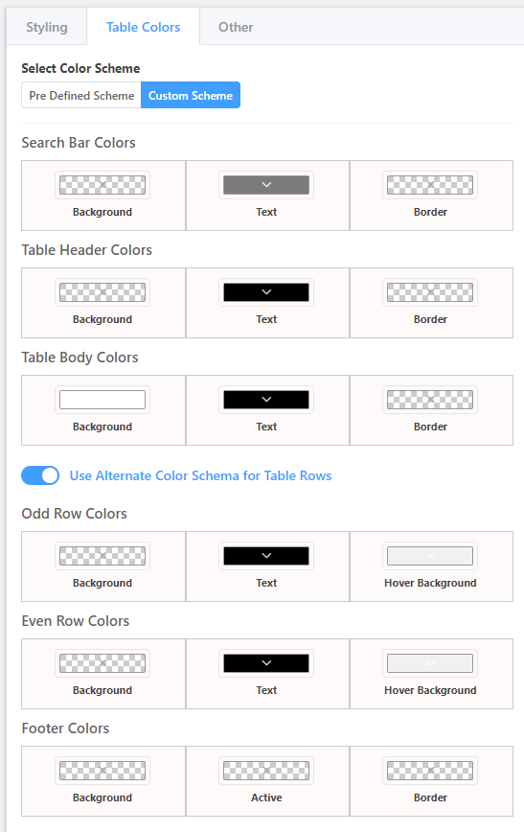
241, 241, 241, 1
255, 255, 255, 1
123, 123, 123, 1

0, 0, 0, 1

Any other tabs/options in Ninja Tables are ones I have not had the need to use, and so have not explored how they function.

