Photo Galleries

Instead of using the built-in wordpress gallery function, use the plug-in “Gallery” to add large amounts of media to a page. You can see it on the left-hand menu in the dashboard, or above the content editor. While you can create a new gallery from the button above the content editor, I have found it glitches out more often than not. Instead, enter the plugin itself to add a new gallery, and we will only use the button above the content editor to insert the gallery after it is made.

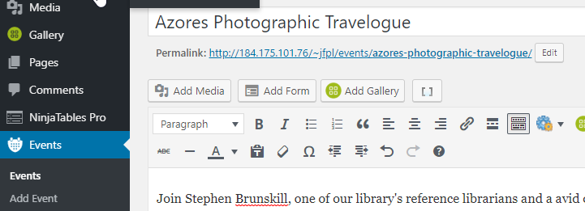

Go to the plugin via the left-hand menu. To create a gallery, click “Gallery” then Add Gallery/Images. You can then either upload images, or, if they were previously uploaded to WordPress’ Media Library, you can import them from there.

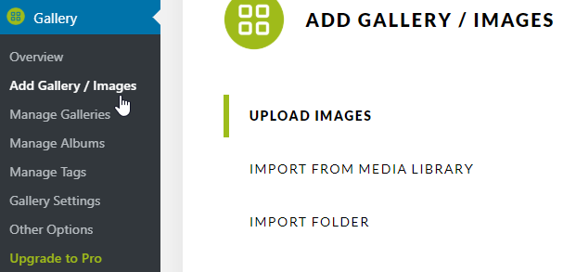
Option 1: Using Upload Images

Create your title, then click “Add Files”

Navigate to the images you would like to upload, and select them, then click “open”.
Then click “Start Upload”
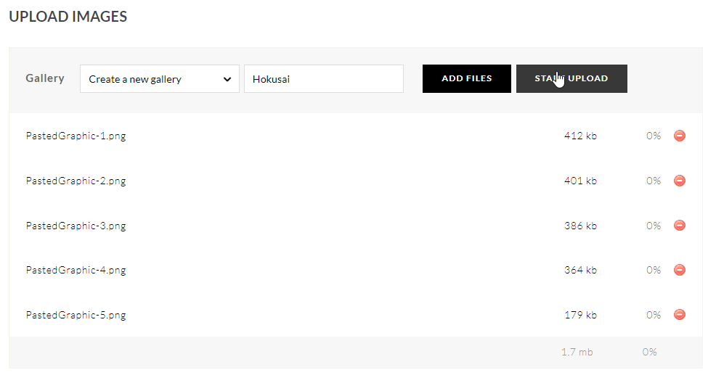

Option 2: Using Import from Media Library
The set up is very similar. Create your title and click “Select Images”

You will now see the WordPress Media interface. Select the images you would like to add to your gallery. (If they are all in a row next to each other, you can click the first image, then hold Shift while you click the last image, and all images between the two will also be selected.
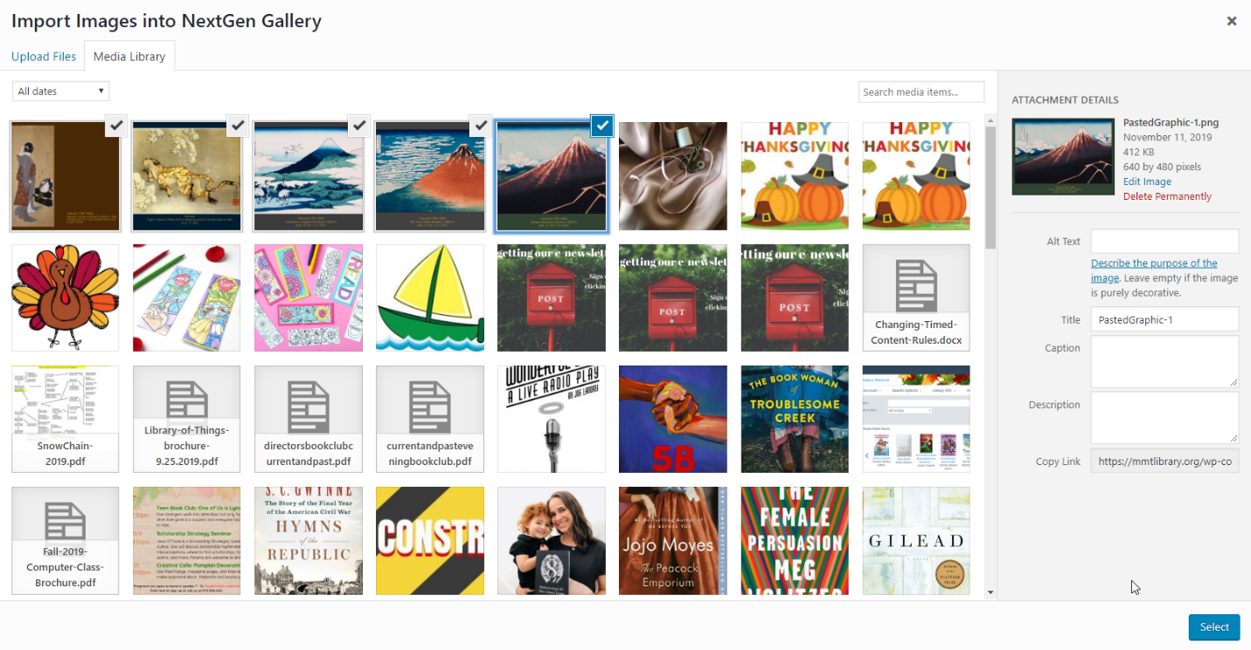
Click “Select” in the bottom right-hand corner of the screen.
The gallery is not fully done yet. Now, you must click “Import [x] Images”

You will see a percentage bar appear in the bottom right hand corner of your screen. Once that is done, you should get this message:
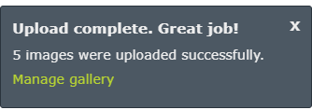

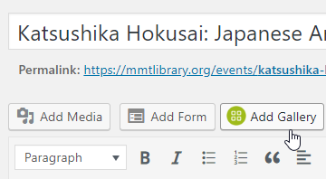
Once your gallery is made:
Go back to the post or event you would like it in.
Now click the “Add Gallery” button above your content editor.

On the next screen, select the Gallery you just made from the drop down menu.
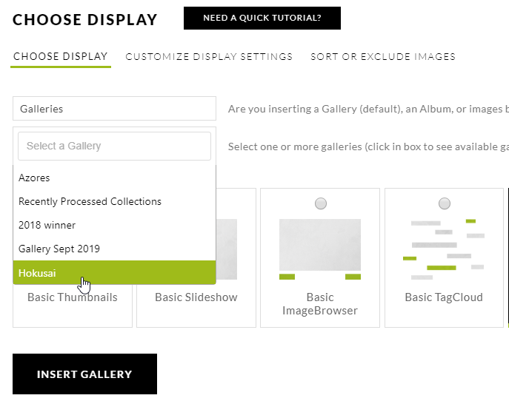
There are many more options for how you would like the gallery to display. I usually use “Basic Slideshow” but feel free to play around. There is also a tutorial button if you would like more information.
For “Basic Slideshow” I also go to the “Customize Display Settings” tab, and turn “Show Arrows” on. This makes it clear that there are more images patrons can view more quickly (rather than waiting for the slideshow to move to see them all).

