Adding and removing Site Announcements

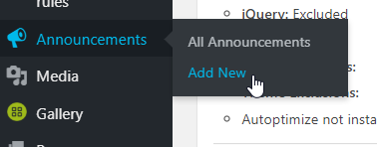
To Add:
From your dashboard, on the left-hand side, go to “Announcements”.
If you hover over Announcements, a new menu will pop up and you can click “Add New”

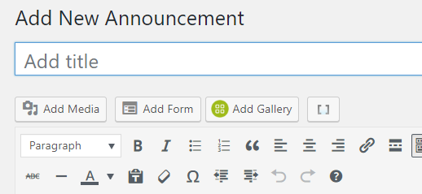

Enter your announcement in the “Add title” bar, leave the main text area blank.

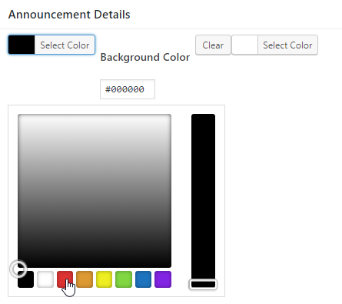
Below the announcement editor, in a section called “Announcement Details” change the background color to red (its default is black).

The background color is the left-side “Select Color” option (it won’t say “Background Color” next to it until you click it) – you can ignore the right side option.

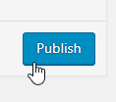

Lastly, on the right-hand side of the editor, click the blue “Publish” button.

To Remove a Site Announcement:

Begin again from your dashboard. Hover over “Announcements” and click on “All Announcements”.

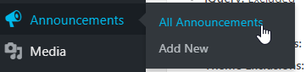

There should only be one, the one you previously made. If you hover over its title, options will appear below the title. Choose “Trash”.
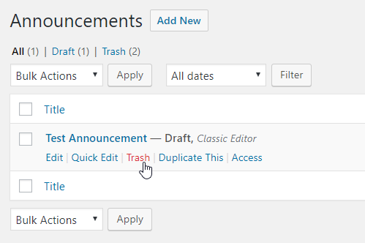

All done!

