Adding a new (non-recurring) Event
Hover over “+ New” on your top toolbar, and choose “Event”.
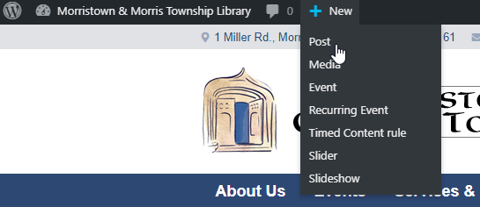
Add your Title and Content.
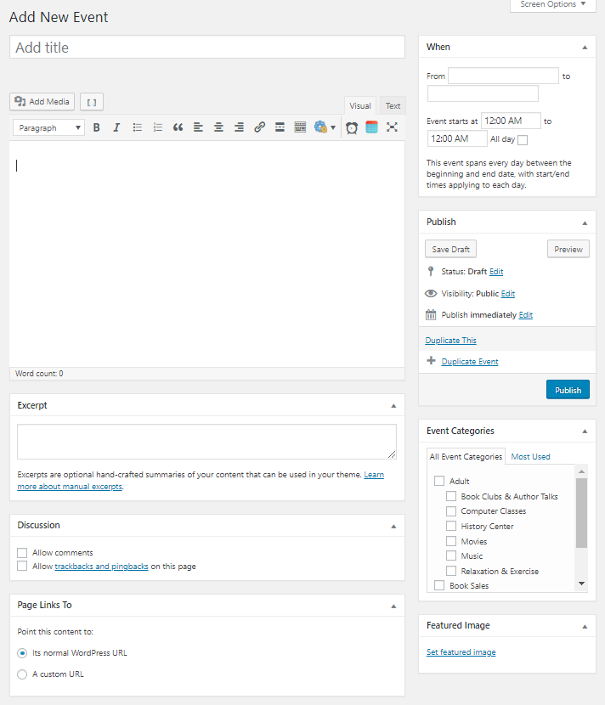
Select your date and starting time.
The “To” fields will auto-populate with the same starting date and time. You can leave these alone, or specify how long the event goes for, if desired.

Always choose at least one applicable category.
For events to appear on the Front Page, you must choose the “Featured” category as well.
Always set a featured image.

From the right-hand menu you can always “Save Draft” or “Preview” before fully Publishing the event. Do not add an excerpt, or change any other settings below the content field.

