Adding a new (recurring) Event
Hover over “+ New” on your top toolbar, and choose “Recurring Event”.
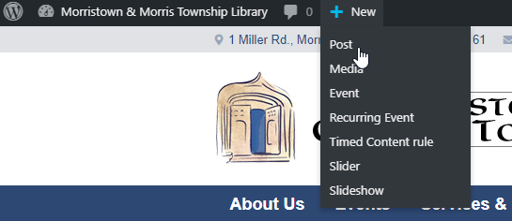
Follow the instructions for non-recurring events, but the Date/Time options will now appear below your content, and ignore the new option to add a location (this does nothing at all). If you want a location noted, just include it in your description.
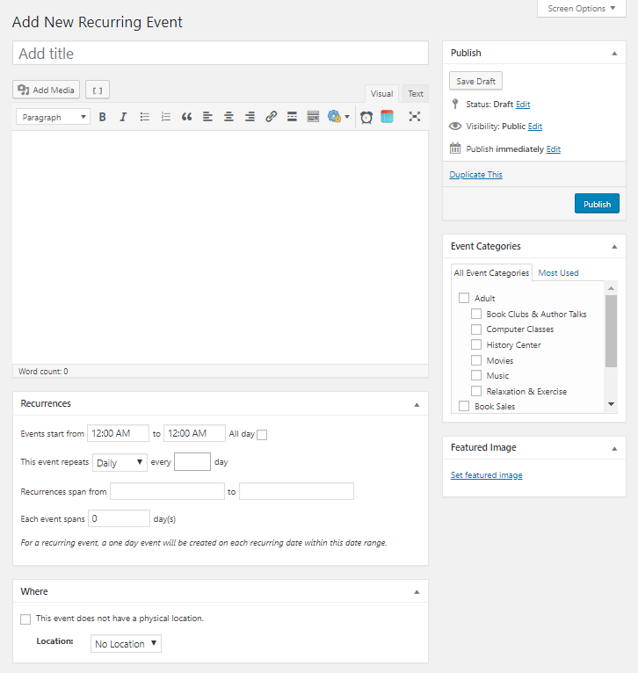

Always choose at least one applicable category.
For events to appear on the Front Page, you must choose the “Featured” category as well.
Always set a featured image.

Always be sure to include a Category and a Featured Image (and a Title and a Description, but that’s obvious, right?).

