Adding and removing Site Announcements (What I usually do is found on Page 3)

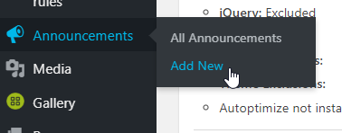
To Add:
From your dashboard, on the left-hand side, go to “Announcements”.
If you hover over Announcements, a new menu will pop up and you can click “Add New”

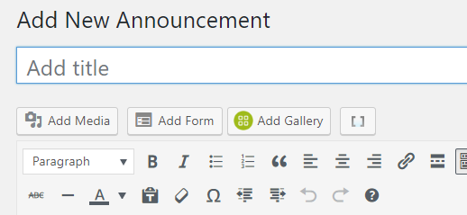

Enter your announcement in the “Add title” bar, you can leave the main text area blank, or add further details here. Patrons will see the information in the main text area only if they click on the title, so it’s best to put the important information in the title area.
Ignore this one
Change this one
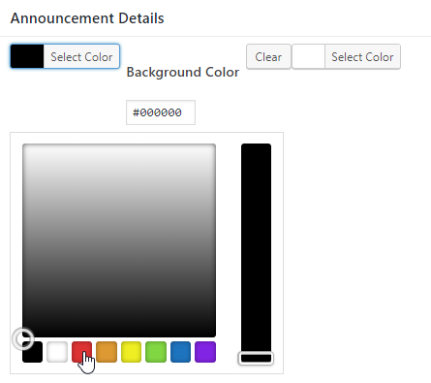
Below the announcement editor, in a section called “Announcement Details” change the background color to red (its default is black).

The background color is the “Select Color” option on the left side (it won’t say “Background Color” next to it until you click it) – you can ignore the right side option.

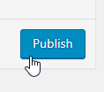

Lastly, on the right-hand side of the editor, click the blue “Publish” button.

To Remove a Site Announcement:

Begin again from your dashboard. Hover over “Announcements” and click on “All Announcements”.

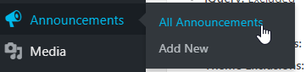

If you hover over an announcements title, options will appear below the title. Choose “Trash”.
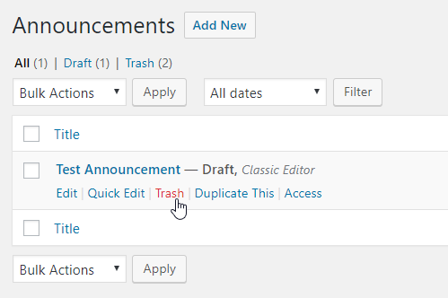

Alternatively:

When an announcement is no longer needed, you can change its status by clicking the “Edit” option beneath the title:
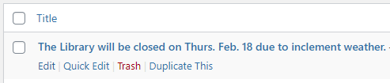
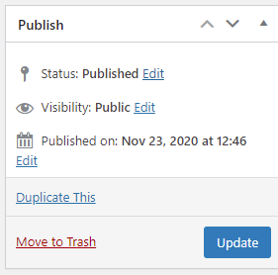
Then, on the right-hand side of the next screen look for the “Publish” box, and click “Edit” next to “Status: Published”

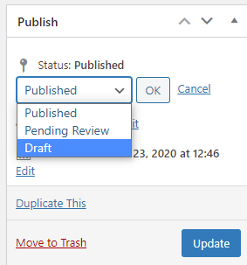

This will bring up a new menu, from the drop-down, choose “Draft” then click “OK” then click the blue “Update” button.
This will hide the announcement from the front page.

Then, next time you need to publish an announcement, you can edit your draft, and then can follow the same steps as above except in the drop down menu change “Draft” to “Published” (then press “OK” then press the blue “Publish” button).

