ART & INDUSTRY

Exploring the relationship between the two with Morristown baker & artist Andrea Lekberg
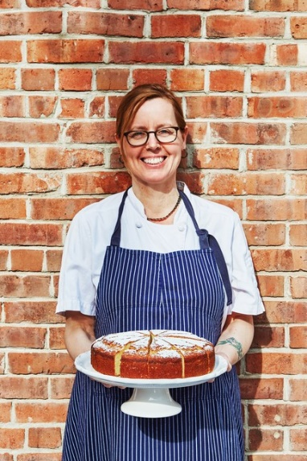
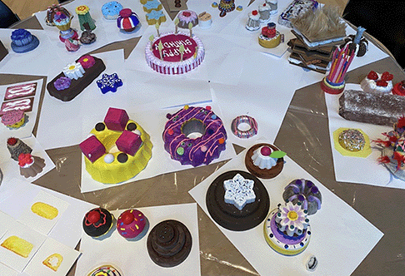
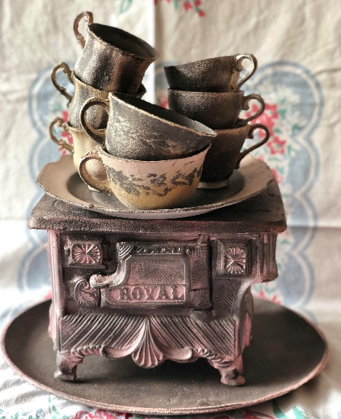

Tuesday, June 25 at 7:00pm

Our Speaker: Andrea Lekberg is a multi-disciplinary artist, chef and citizen of the Oglala Lakota Oyate. Lekberg has exhibited at the Sioux Indian Museum, Akta Lakota Museum, Heritage Center at Red Cloud Indian School, and The Museum of the Plains Indian. She was the 2016 recipient of the Morris Arts Creative Placemaking Award, acknowledged in 2022 by Congresswoman Mikie Sherrill as a NJ Hero, and received the Melody Whitelaw Award from Morristown Women in Business in 2024.

Andrea Lekberg, owner of The Artist Baker in Morristown, will give a talk and slide show of her recent project at The John Michael Kohler Art Center in Sheboygan, WI. Andrea was part of the JMKAC’s 50th Anniversary of the “Arts/Industry” program in which artists are invited to create art in the Kohler Factories. Having done the residency in 2001, Andrea opted out of working in the factory at that time but returned in 2024 to work with the Kohler community to talk about the connection between the pastry and manufacturing industries.

For her residency, she collaborated with JMKAC staff to build a mock pastry kitchen in the gallery, where she put visitors to work creating “pastries” made of materials such as cardboard, papier mâché, and foam. While others worked the assembly line, Andrea spoke with them about the connections between production at the bakery and the production at the Kohler Co. factory.

